Virden, Bargeloh Latest PHS Football Hall of Fame Inductees

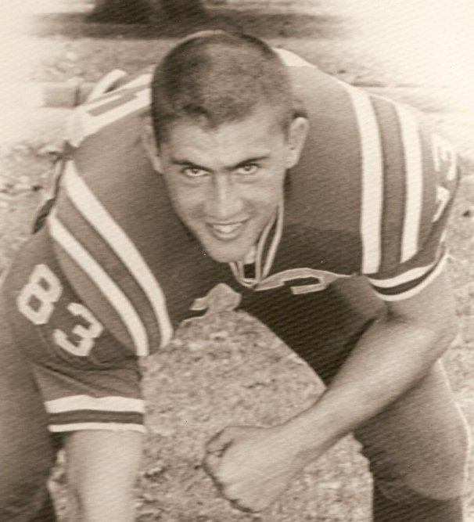
Two major award winners are the latest members of the Parkersburg High School Football Hall of Fame.
Gary Virden, an outstanding end in the early 1960’s and Jim Bargeloh, one of the top running backs in PHS history, have been selected to be enshrined prior to the St. Albans game at Stadium Field on Sept. 23.
Virden was a four-year letter winner in football and baseball prior to graduation in 1964 and made all-state in both sports. As a junior on the 9-1-1 state runner-up team of 1962 he won the Ken Hunt Award as the state’s outstanding lineman as an offensive and defensive end. As a senior the Big Reds went 8-2 under coach Russ Parsons.
A high school All-American, Virden received a scholarship to Morehead State University where he played football for four years and was an All-Ohio Valley Conference selection as a linebacker. He has been married for 47 years with two daughters and two grand children. He resides in Lakeland, Fla., where he retired from teaching after 30 years.
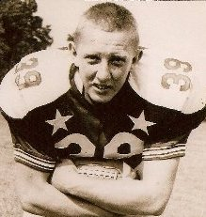
Jim Bargeloh earned the ultimate West Virginia football honor in 1957 when he was named the Kennedy Award recipient. As a sophomore he led the team in rushing and scored six touchdowns and a junior he earned first team all-state honors while scoring 11 touchdowns and rushing for 750 yards on a 7-3 team for coach Russ Parsons. His senior season saw the speedy Bargeloh gain 1,023 yards on just 162 carries while scoring 13 touchdowns. The Big Reds again finished 7-3 that year.
The newest Hall of Famer, Bargeloh stands 11th on the all-time career rushing totals as a Big Red with 1,922 yards and finished with 180 career points.

